**Launch Cloudant DB**

**Step 1: Login to IBM Cloud Account**

Navigate to the [IBM Cloud Login page](https://cloud.ibm.com/login) and sign-in. Once signed in, you should be presented with IBM Cloud Dashboard Page:

### 

### Step 2: Select "Create Resource button"

Once on the Dashboard Page, Select the "Create Resource" button (in the upper right hand corner):

### 

### Step 3: Search "Cloudant" on Create Service Page

Once you have selected the "Create Resource" button, you will be navigated to the IBM Cloud service page which holds all services in the IBM Cloud catalog. In the Search bar on the page, enter the word "Cloudant":

### 

### 

### Step 4: Select "Cloudant" Service

Once you have searched "Cloudant", select the service named "Cloudant" that should appear in the auto-search dropdown:

### 4-Search_Cloudant_Selected-Highlight Step 5: Configure Cloudant Service for Use

Once we select the Cloudant Service option we should be presented with the Cloudant Service Configuration page, that looks like this:

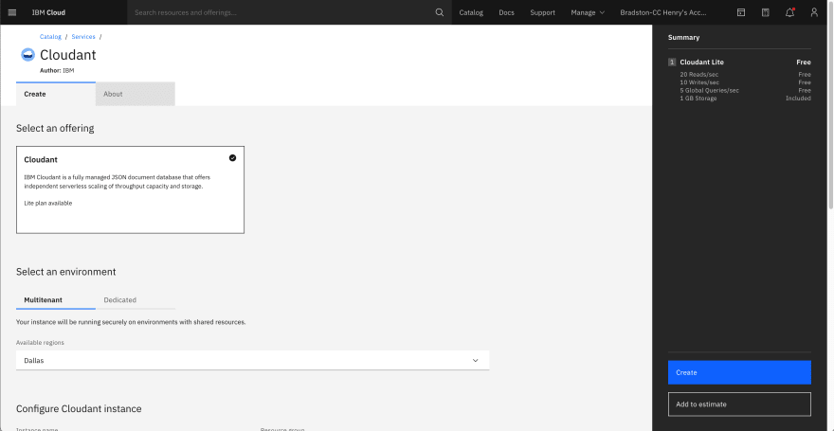 On this page we will be doing a few quick things.

First, we ensure that the "Multitenant" environment option is highlighted (ensures free instance of Cloudant) and select the location nearest to us in from the Region select drop-down:

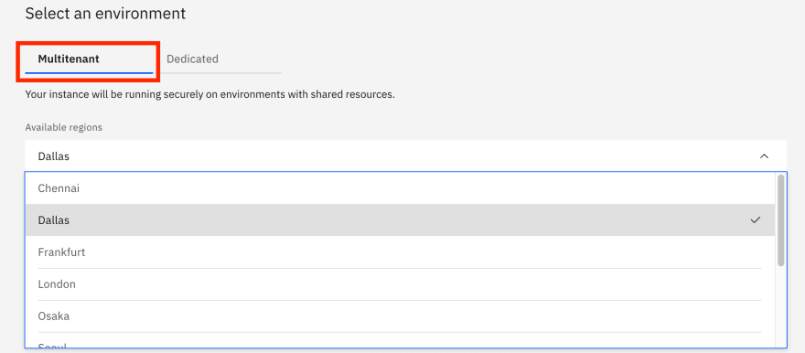 Once we've done that, we will give our instance of this Cloudant service a name (whatever you'd like), select a Resource group ("Default" is fine), and add a searchable tag for the future, if we so desire:

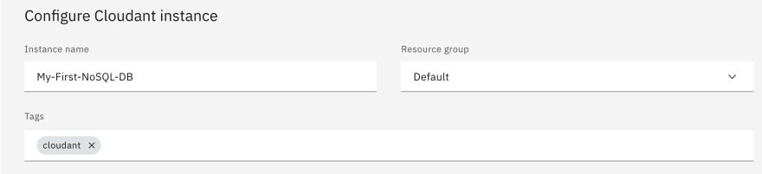 Finally, we will select the method that we would like to authenticate to our Cloudant service. If you are just learning Cloudant, I recommend selecting the "IAM and Legacy Credentials" options as it gives you more flexibility in the future. Also, ensure that the "Lite" plan is selected as it is the **Free** version of Cloudant:

### 10a-Select-IAM_and_Legacy-Crop11a-Select_Lite_Plan-Crop Step 6: Creating Your Cloudant Service

Once you have finished configuring your Cloudant service, just click the "Create" Button in the bottom right-hand section of the page. It will be begin creating the service and you may receive a dialog informing you it is provisioning. The Provisioning process usually takes around 2-3 minutes to complete:

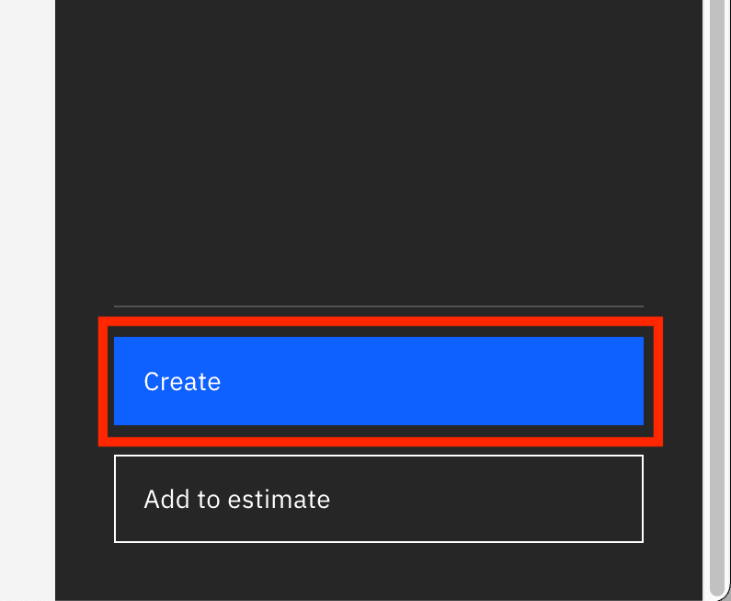

### 12a-Creating_Service-Corp 12b-Creating_Service-Crop Step 7: Open Your Newly Create Cloudant Service

After you create your Cloudant service, you should be automatically navigated to IBM Cloud Resource page, if not, [click here](https://cloud.ibm.com/resources) to navigate there. Once there, wait until your newly created service (under the "Service") changes from "Provision in Progress" to "Active":

### 14-Cloudant_Service_Active-Crop Once the service is "Active", Open the service by selecting it's name: You should then be presented with your Cloudant services "Service Overview" page (which holds general information about your service): 16-Cloudant-Service-Overview Step 8: Open/Launch Your Cloudant NoSQL DB Environment

Now that you have successfully created your service and navigated to its overview page, let's launch your Cloudant NoSQL DB Environment. In the top right corner of the page, Select the "Launch" button:

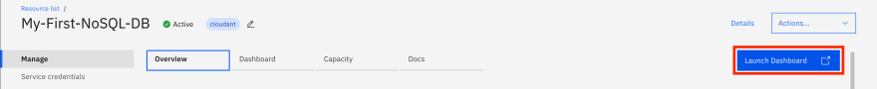 And just like that you should be presented with your brand-new Cloudant NoSQL DB, ready to be leveraged in any way you so like:

**Step 9: Create Databases**

